

|  |
| --- |
| Capstone Project User Manual |

|  |
| --- |
| **Rental House Finding System Team | FPT University** |
| **Hanoi, 28th Feb 2013** |

Table of Contents

1. Visitor 2

1.1. Search 2

1.2. Advanced Search 3

1.3. View Post Detail 4

1.4. Add Post 5

1.5. Edit Post 6

1.6. Delete Post 7

1.7. Renew Post 8

1.8. Register 9

2. User 9

2.1. Login 9

2.2. Logout 10

2.3. Edit user profile 10

2.4. Change password 12

2.5. Recover password 12

2.6. View favorite list 13

2.7. Add favorite 13

2.8. Remove favorite 14

2.9. Compare 15

2.10. Manage post 17

2.11. Manage payment 17

## Visitor

### Search

* + - Navigate to homepage
    - Select type of house, province, and district where you want to search
    - Enter additional keyword
    - Click search, or hit Enter

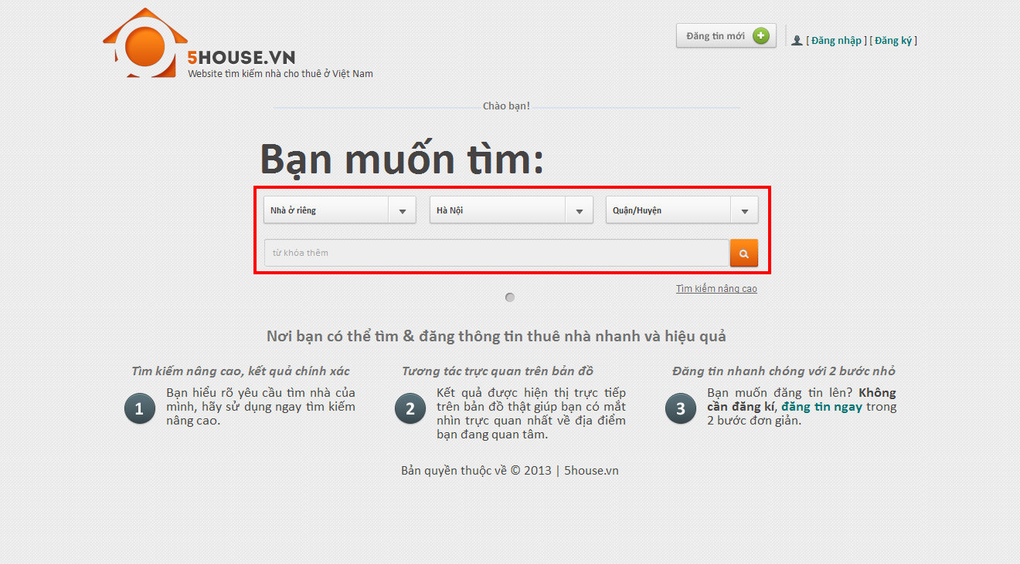

## Advanced Search

* + - Navigate to homepage
    - Click “Tìm kiếm nâng cao”
    - Select type of house, province, and district where you want to search
    - Provide desired price range and area range (not required)
    - Provide information concerning facilities priorities. There are 3 values of priority: Thấp, Vừa, Cao. Unpicked facilities will be ignored.

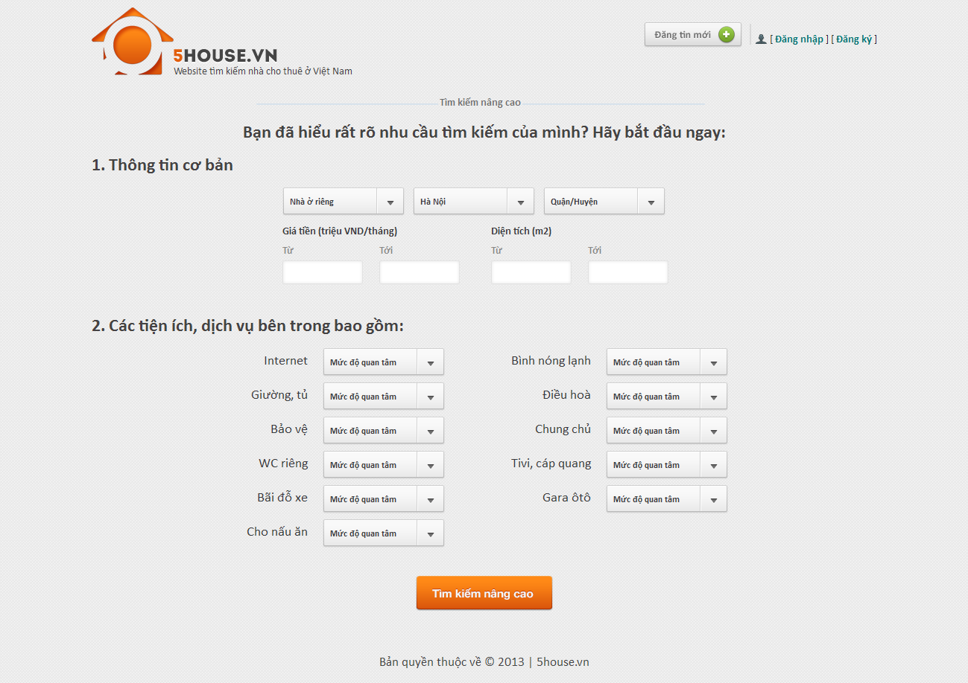

## View Post Detail

* + - Perform a search then click on a result on the list or a marker on the map, or enter the link directly to browser’s address bar

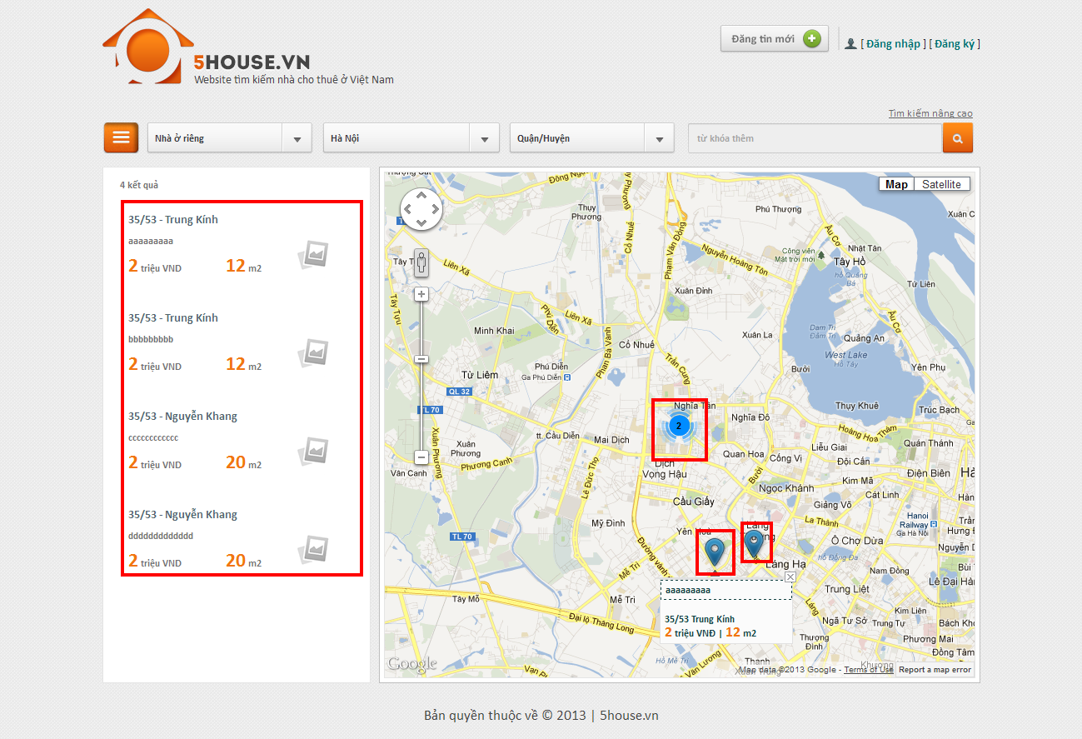

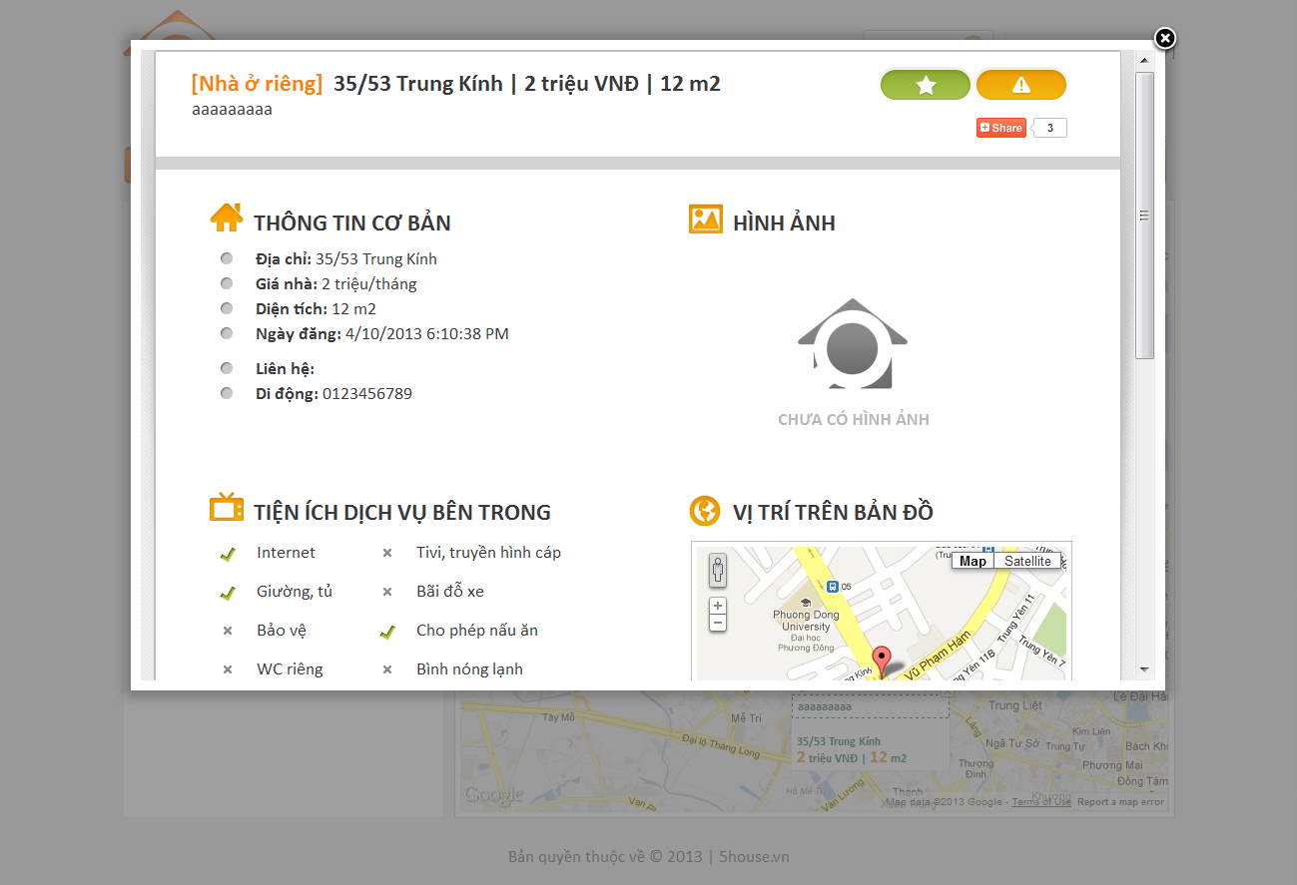

## Add Post

* + - Click on “Đăng tin mới” button on top of any page
    - Enter input as prompted

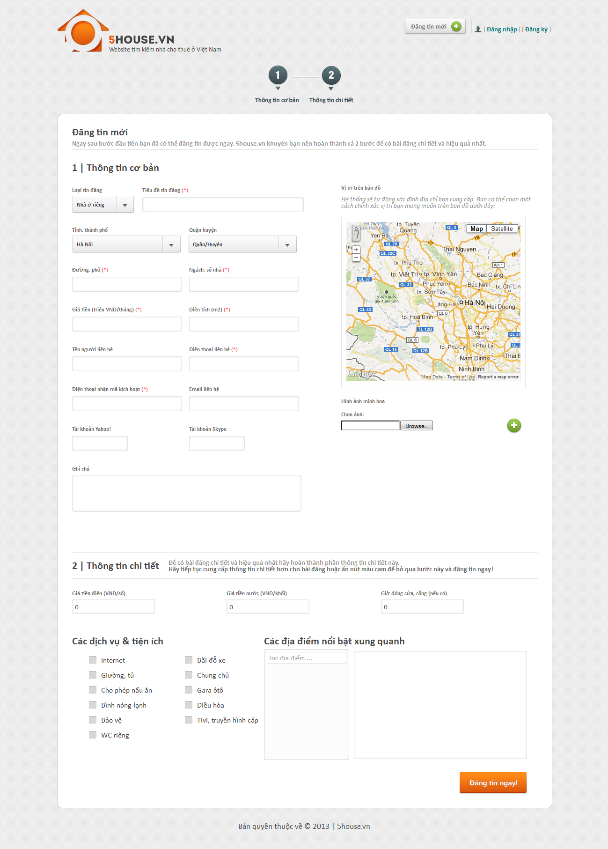

## Edit Post

* + - Enter the link provided when posting into the browser
    - Enter the provided password
    - Edit post details
    - Click “Lưu thay đổi” button

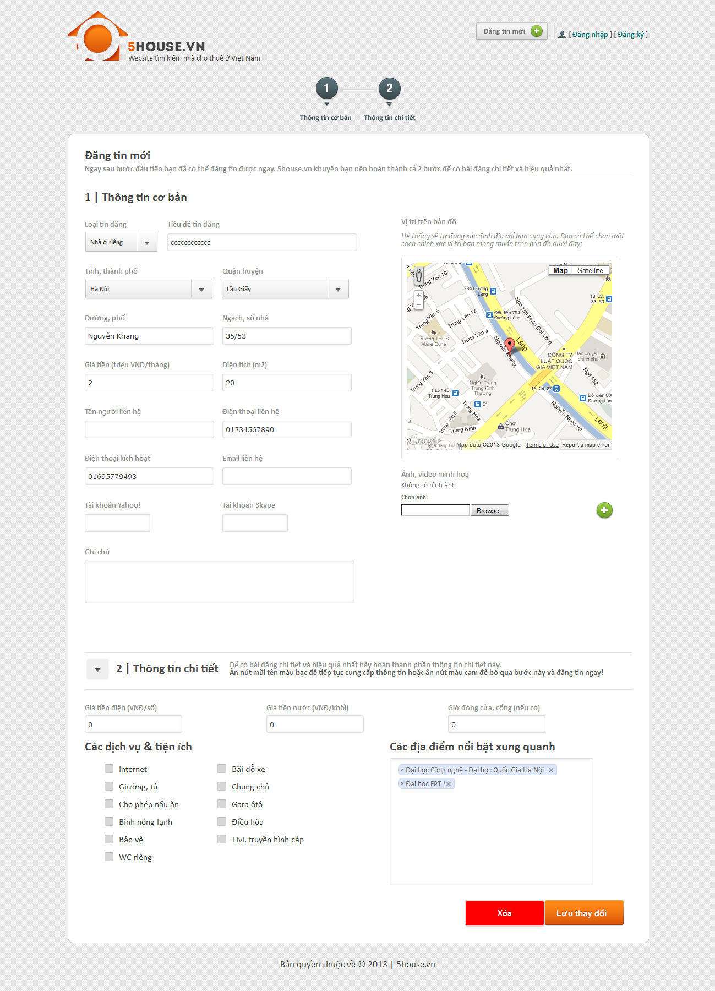

## Delete Post

* + - Enter the link provided when posting into the browser
    - Enter the provided password
    - Edit post details
    - Click “Xóa” button



## Renew Post

* + - Send and SMS with the following content to our SMS service
      * MS [password]

With [password] is the one that was provided when posting.

## Register

* + - Click on “Đăng ký” link
    - Provide details as prompted
    - Click “Đăng ký” button

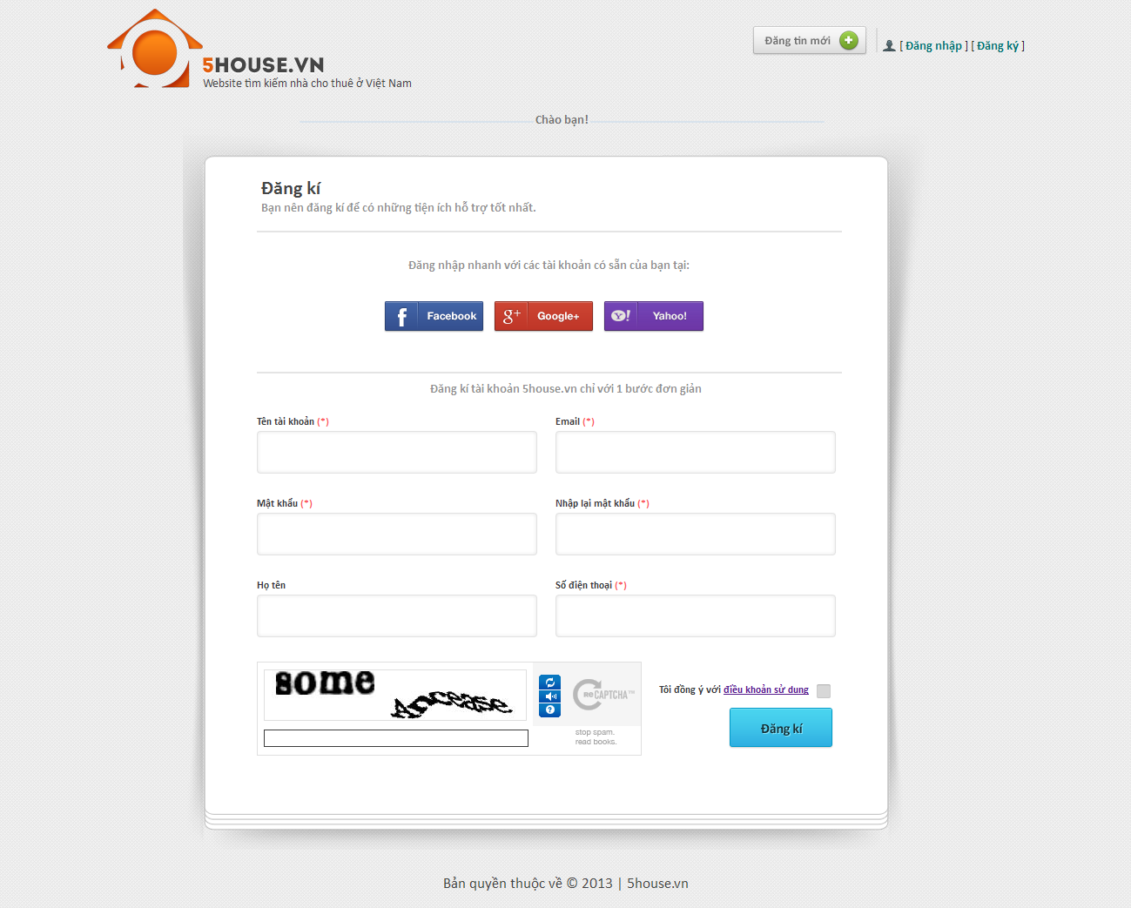

## User

## Login

* + - Click on “Đăng nhập” button
    - Login with registered username and password, or use Facebook/Google/Yahoo ID

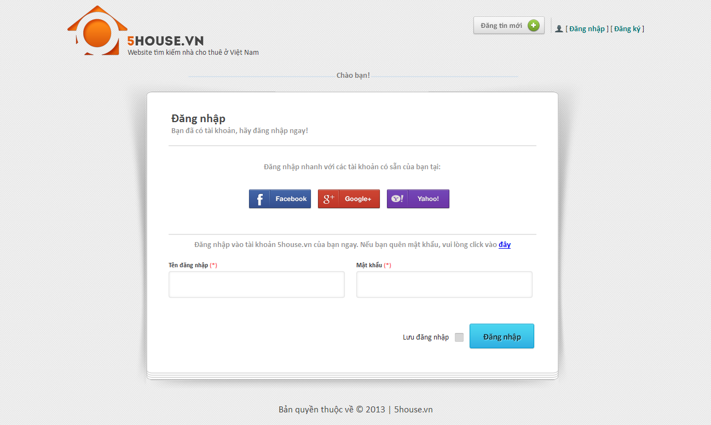

## Logout

* + - User must have logged into the system
    - Click on “Thoát” button

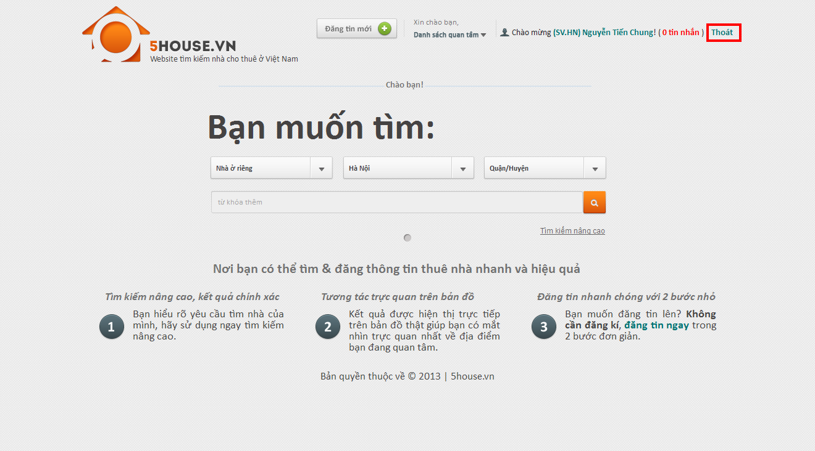

## Edit user profile

* + - Login to the system
    - Go to User Control Panel by clicking on the displayed username on top of the page
    - Click “Thay đổi thong tin” button
    - Edit user details
    - Click “Lưu thay đổi” button

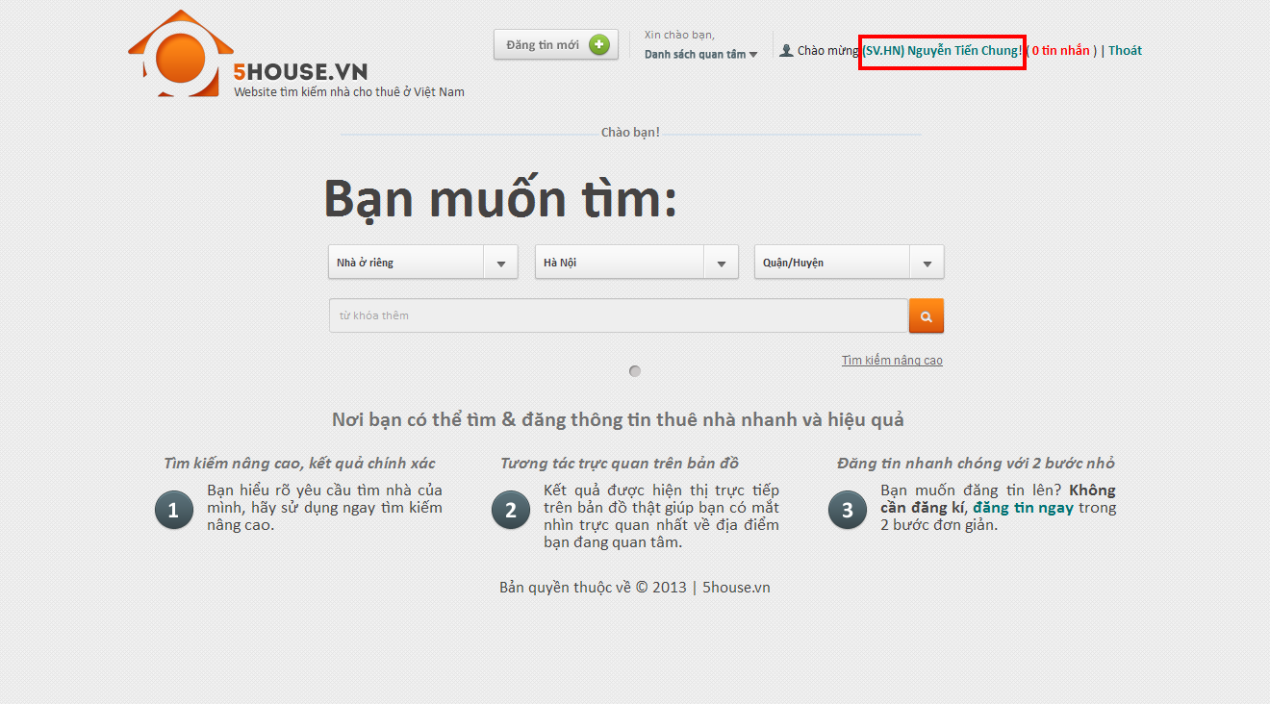

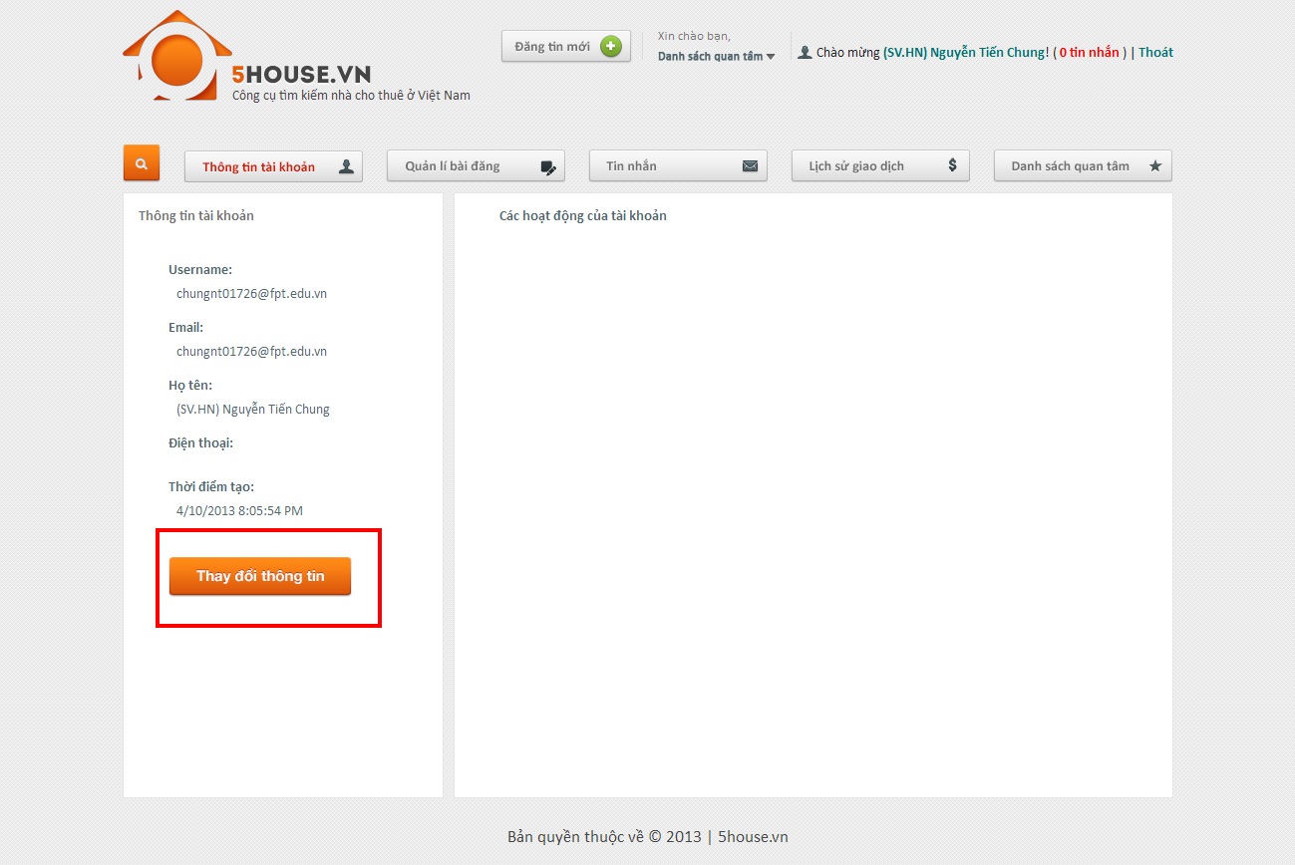

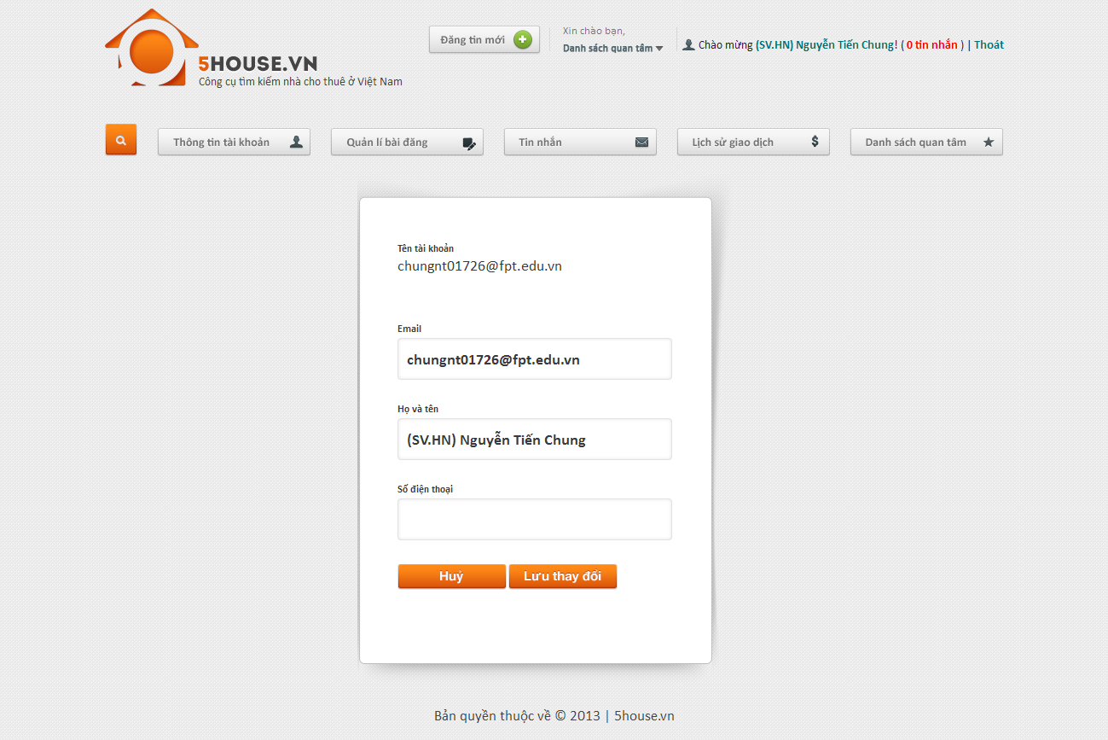

## Change password

* + - Login to the system
    - Go to User Control Panel
    - Click on “Đổi mật khẩu” button
    - Provide new password
    - Click “Lưu thay đổi”

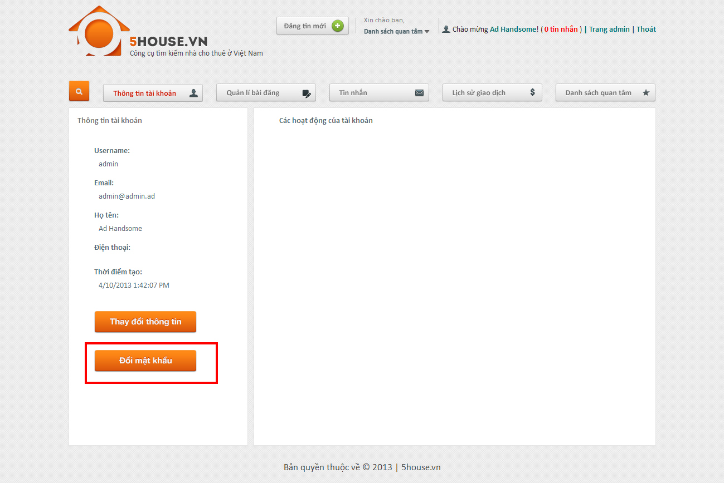

## Recover password

* + - Go to login page
    - Click on password recovery link
    - Click button

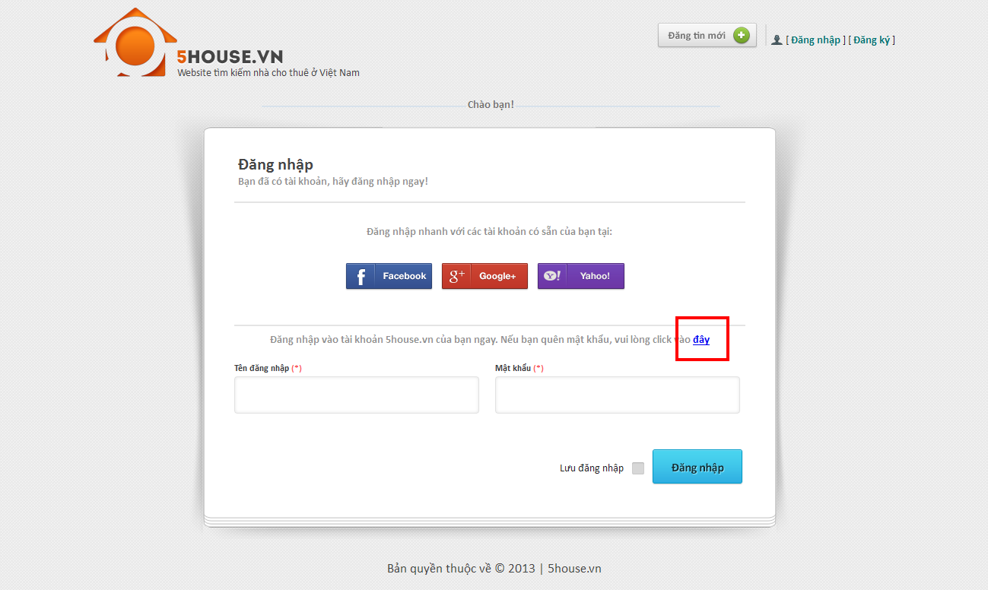

## View favorite list

* + - Go to User Control Panel
    - Click on “Quản lý bài đăng” button

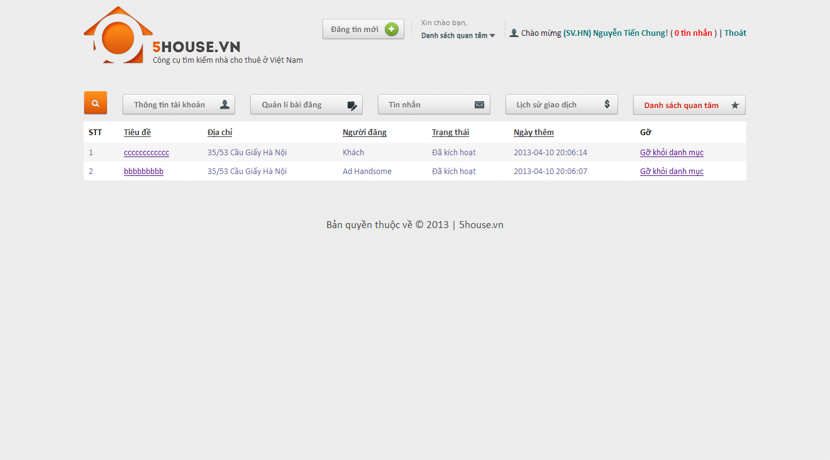

## Add favorite

* + - View a post which is not in favorite list
    - Click on Favorite button

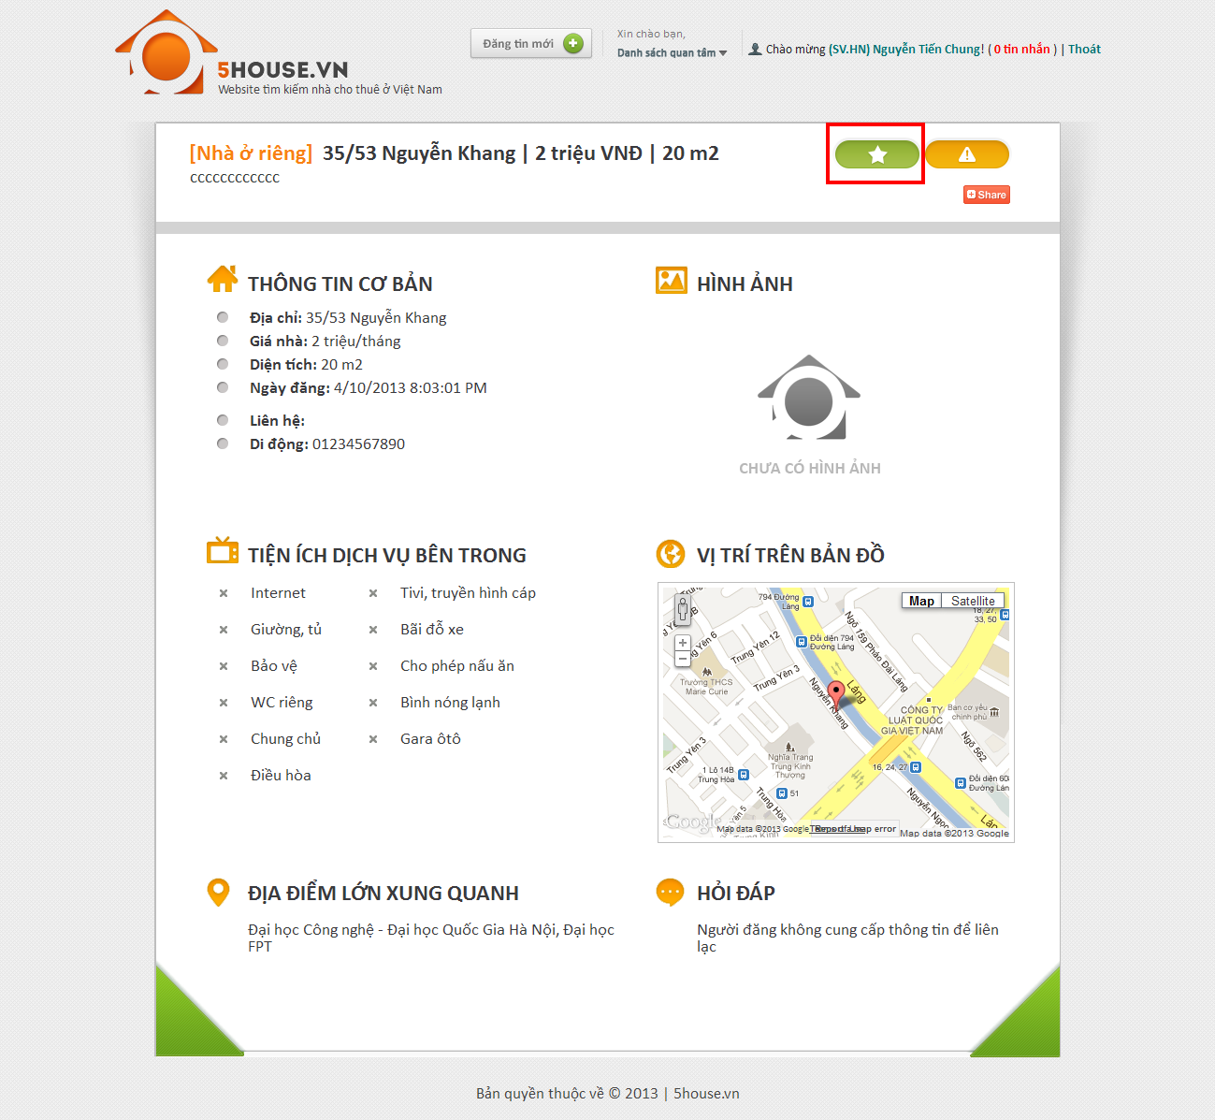

## Remove favorite

* + - View a post which is currently in favorite list
    - Click on Favorite button

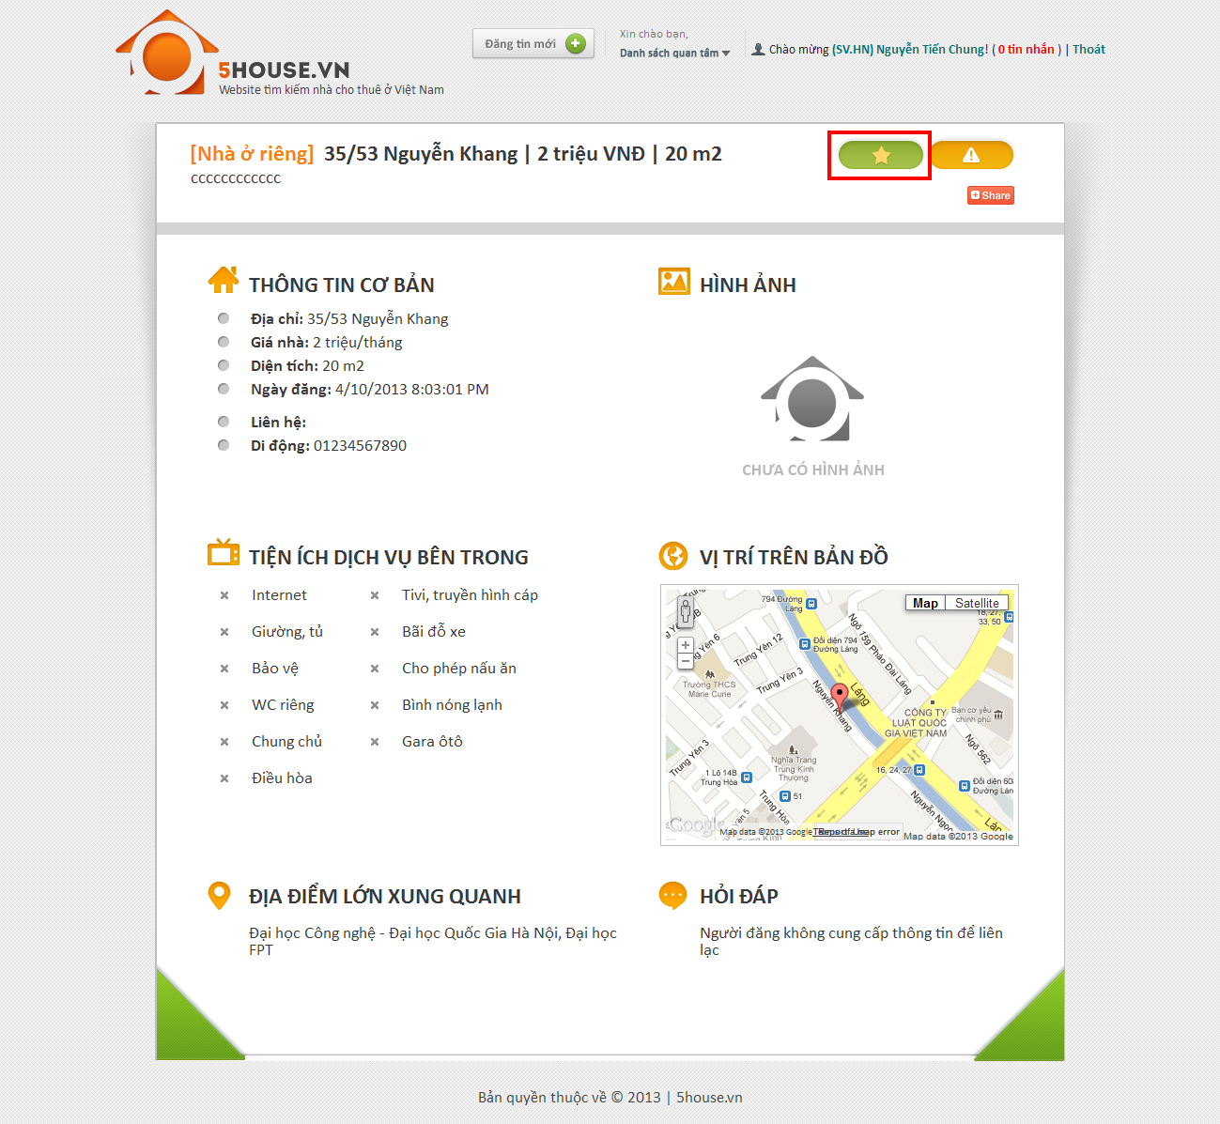

## Compare

* + - Add at least 2 post to favorite list
    - Click on “Danh sách quan tâm” link
    - Check at least 2 post
    - Click “So sánh”

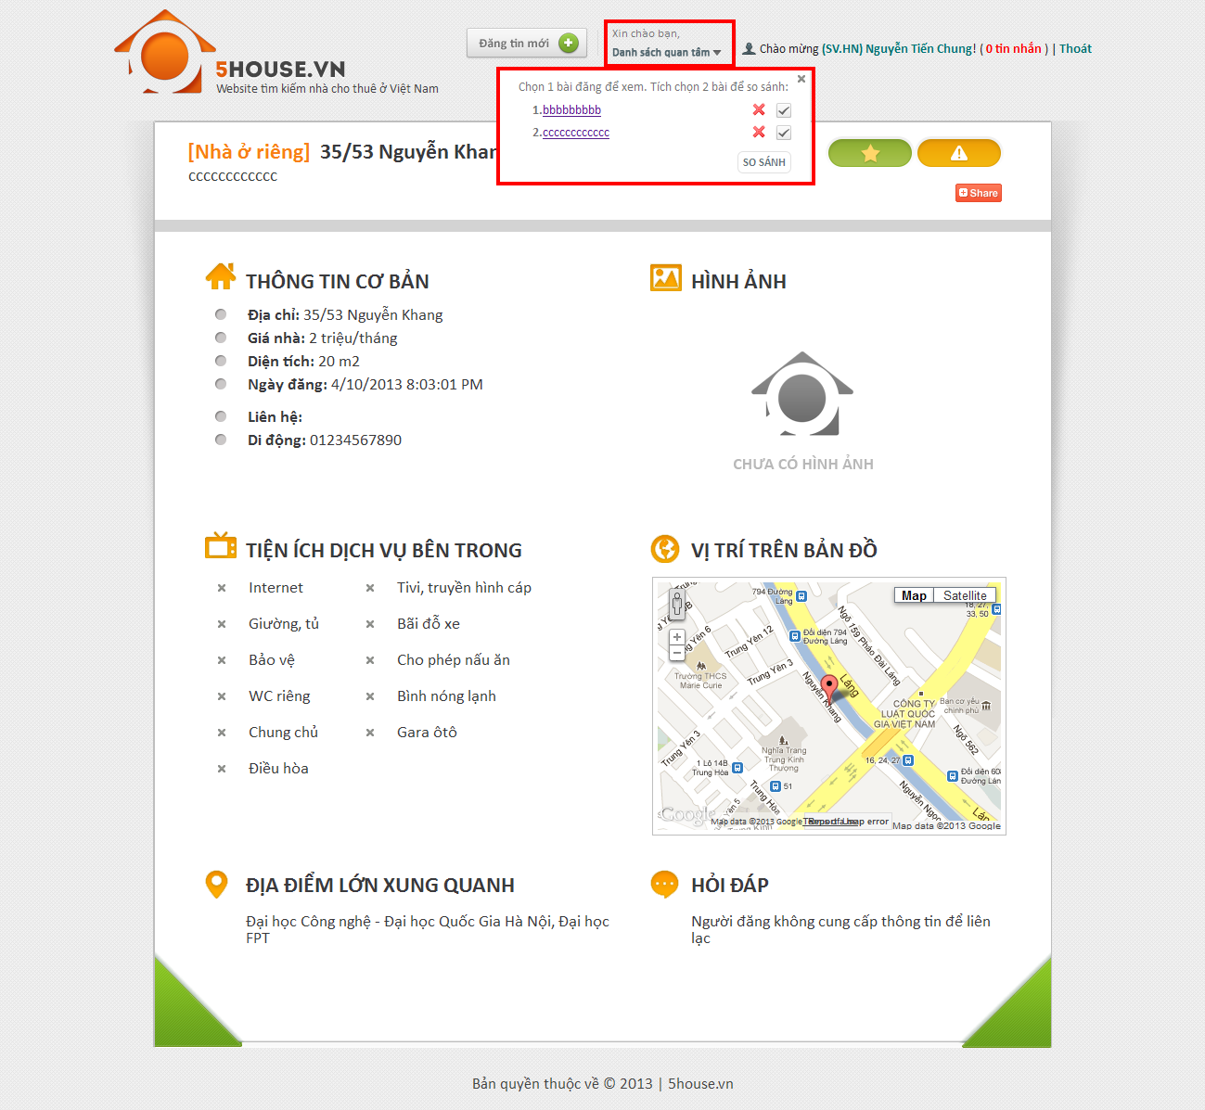

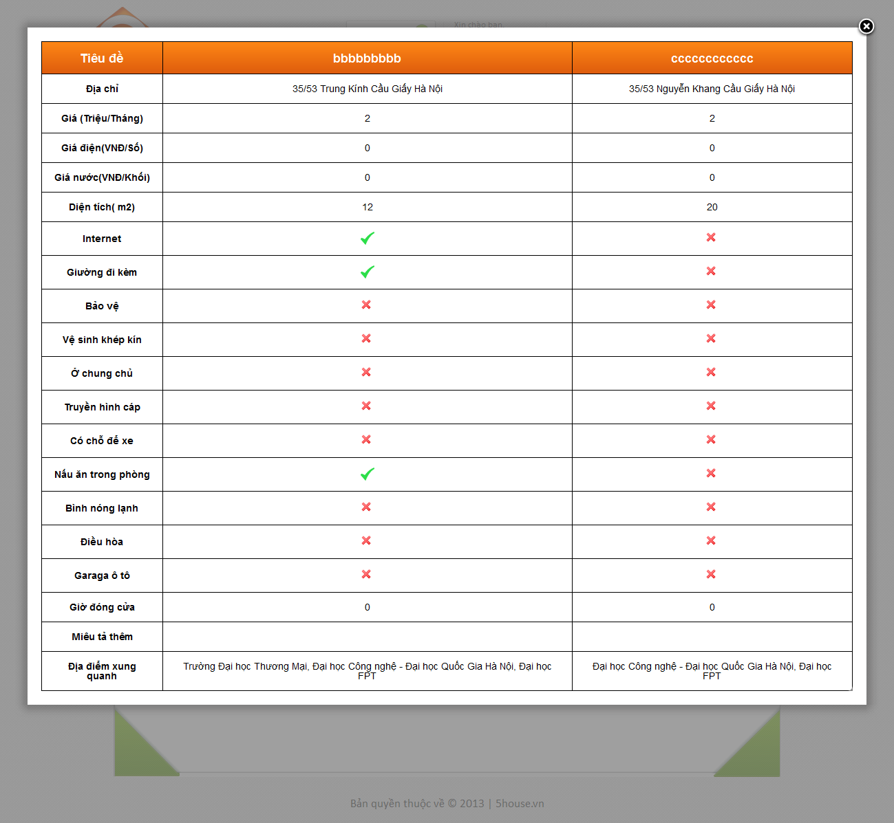

## Manage post

* + - Go to User Control Panel
    - Click on “Quản lý bài đăng” button

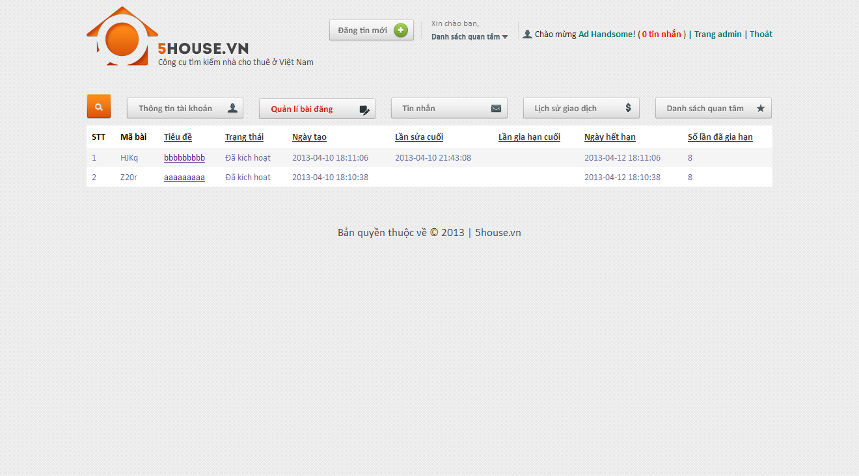

## Manage payment

* + - Go to User Control Panel
    - Click on “Lịch sử giao dịch” button

## C:\Users\Public\Pictures\2.11.png

See Appendix for more detail.